**Ideation Phase**

**Brainstorm & Idea Prioritization Template**

|  |  |
| --- | --- |
| Date | 27 JUN 2025 |
| Team ID | LTVIP2025TMID59165 |
| Project Name | Citizen AI – Intelligent Citizen Engagement Platform |
| Maximum Marks | 4 Marks |

# Brainstorm & Idea Prioritization Template:

Brainstorming provides a free and open environment that encourages everyone within a team to participate in the creative thinking process that leads to problem solving. Prioritizing volume over value, out-of-the-box ideas are welcome and built upon, and all participants are encouraged to collaborate, helping each other develop a rich amount of creative solutions.

# Step-1: Team Gathering, Collaboration and Select the Problem Statement

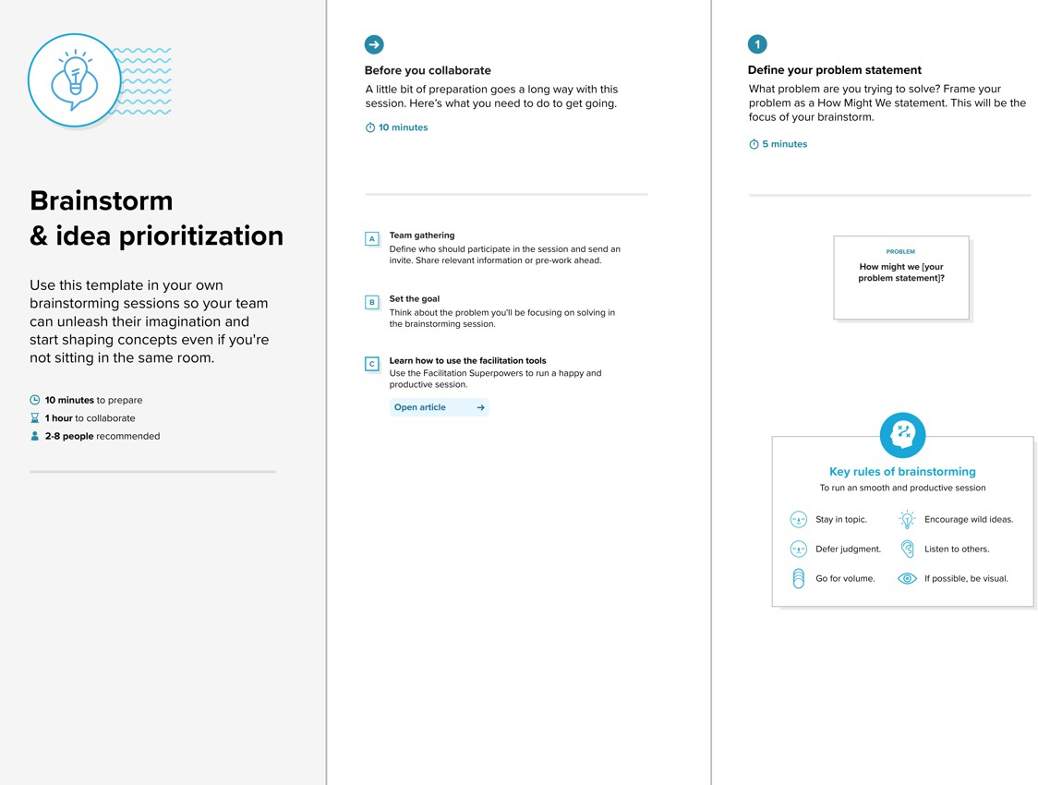

**The brainstorm and idea prioritization template helps you:**

* Prepare for your brainstorming session
* Define your problem statement
* Collect ideas and gather feedback from everyone
* Group ideas by theme
* Prioritize your solutions and get aligned on next steps

# How to use the brainstorm and idea prioritization template:

To use the Mural brainstorm and idea prioritization template with your team, follow the steps outlined below.

## Step 1: Define goal and invite stakeholders

The first step in the process is to clearly define the goal(s) of your brainstorming session. What problem(s) are you trying to solve? At this stage, you should also carefully select a list of stakeholders who will participate in your brainstorming session.

## Step 2: Define your problem statement

The next phase is to create a problem statement that clearly identifies the issue. Frame your problem statement as a ‘How might we?’ question (e.g., ‘How might we shorten wait times for customer service calls?’).

## Step 3: Brainstorm!

Have each stakeholder brainstorm as many ideas for possible solutions as they can in a given time.

Pro-tip: Use Mural’s private mode feature to avoid groupthink while brainstorming, allowing everyone to work independently even while synchronous.

## Step 4: Group ideas together by theme

Once you’ve generated as many ideas as possible with your team, it’s time to look carefully at the results. What are the natural themes that emerge from your ideation? How should they be grouped together to inform potential solutions?

## Step 5: Prioritize solutions

Now that you’ve refined your ideation into themes, you can effectively prioritize the results using the chart tracking importance vs. feasibility.

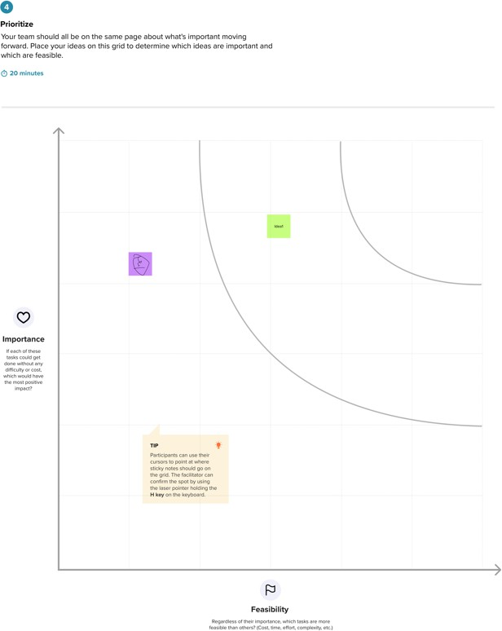

# Tips for running a brainstorming & idea prioritization session:

To run a successful brainstorming session and build an idea board, you should:

* Make sure you invite stakeholders representing all aspects of the issue at hand so that you can avoid blind spots when brainstorming solutions
* Use Mural’s timer feature to keep things on track while brainstorming, and use private mode to avoid groupthink; then, you can leverage a voting session to determine the best next steps!
* Keep a record of your brainstorming so that you can return to your ideas and revisit questions over time — this may help generate even more solutions in the future

# Brainstorming examples and techniques:

There are many established (and highly effective!) brainstorming techniques that you can use to help boost your team's engagement and creativity. We've built out a [definitive guide to brainstorming](https://www.mural.co/blog/brainstorming), as well as [tips for how to facilitate brainstorming sessions,](https://www.mural.co/blog/run-a-brainstorming-session) so that you can get the most out of your time together — regardless of where you are.

But before you begin, it's important to establish the rules of engagement — check out our piece on [7](https://www.mural.co/blog/brainstorming-rules) [ground rules for brainstorming](https://www.mural.co/blog/brainstorming-rules) to see why.

# Common brainstorming techniques:

* [Rapid ideation](https://www.mural.co/blog/rapid-ideation): This approach is just like it sounds — generate as many ideas as you can (quantity over quality, then filter later)
* [Brain-netting](https://www.mural.co/blog/brain-netting): This is focused on connecting hybrid and remote teams, capturing everyone's feedback with digital tools, and then connecting related ideas
* [Round robin](https://www.mural.co/blog/round-robin): Here, participants write their ideas down during a set time period, before setting them aside to return to later, or passing them along to the next participant to build or comment on
* [Rolestorming](https://www.mural.co/blog/rolestorming): Participants role-play to place themselves in the mindset of a customer or persona (or even a famous person) to help build empathy and examine things from different perspectives
* [Mind mapping](https://www.mural.co/blog/mind-mapping): This is a way to brain-dump and build out as many related ideas as possible, starting from a central theme (note: Mural now offers [AI-assisted mind mapping tools](https://www.mural.co/blog/mural-ai))